Midterm Review Answer Key
Packet #1
Pg12 Crossword Pg 6
Across Down 13. Dependent; Independent
1. Density 2. Thermometer 14. Dependent; Independent
3. second 3. Si 8.D
6. mm 5. Cm 9.E
8. derived units 5. Dm 10.B
9. cubic meters 7. Meter stick 11.C
11. temperature 10. Celsius 12. A
14, standard 12. Absolute 21. Experimental Results
15. Liter 13. Gram 22. Scientific Journals
19. meter 16. Kelvin 23. Verify
20. volume 17. Deci 24. Experiment
21. centi 18. Length 25. Hypothesis
22. balance 25. mL 26. Valid
23. pie 27. Theory
24. time 28. Law
26. graph

Soil Review
1.D 7.A 12.D 16. D
2.B 8. F 13.A 17. D
3.C 9. C 14. D 18. D
4.A 10.E 15. C
5.B 11.G
6.D

19. Parent or Bed Rock
20. Soil
21. The rock which was weathered to create sediment or soil
22. Residual
23. Does not match the rock underneath it.
24. The carrying away of rock or soil
25. They break up the soil and remove vegetation making soil more likely to wash away
26. The soil there is thin/ limited to begin with
Midterm Review Answer Key
Packet #2
Pg 122 Testing Concepts
1. C 2. A 3. B 4.L 5. E 6. G 7. I 8. H 9. F 10. D 11. D 12. B 13. C 14. A
15. B 16. A 17. B 18. B 19. B 20. D 21. D 22. C 23. D 24. C 25. C

Applying Concepts
- Biotic 5. Predator/ Prey
- Abiotic 6. Parasite
- Abiotic 7. Predator/Prey
- Biotic 8. Mutualistic

A Salt Marsh Food Web
Part A.
- Land and water plants
- Insect, vole, snail, smelt, sandpiper, crayfish
- Heron, vole, hawk, blackbird, rail, sandpiper
- Sandpiper and vole
- Hawk and Owl
- They don’t consume anything but they provide the nutrients for everything in the ecosystem
Part B.
- B 2. D 3. C 4. A
Understanding Concepts
- Lava cools
- Ash settles on lava rocks
- Wind carries spores
- Pioneer species break down rocks
- Soil Forms
- Large plants grow
- Animals arrive

Biotic Relationships
- Symbiosis 22. Matter… Energy
- Mutualism 23. Solar… Chemical
- Parasite 24.Thermodynamic
- Parasite & Host 25. Organisms… Food
- Commensalism 26. Usable… Decreases
- Commensalism 27. Pyramids
- H 28. Trophic Level… Links
- G 29.tertiary level consumer
- F 30. 10
- D 31. Fifth-level consumer
- A 32. T
- I 33.F
- B 34.T
- E 35.F
- C 36.T
- Producer 37.T
- Second level
- Rabbit/ Herbivore
- Secondary consumer
Basic Ecology Crossword
Across Down.
5. Biotic
6. Producer 1. Abiotic
8. Competition 2. Trophic level
10. Climax 3. Fungi
11. Succession 4. Prey
12. Community 7. Biosphere
13. Heterotroph 9. Resource
17. Adaptation 10. Consumer
21. Primary-community 13. Herbivore
24. Ecology 14. Carrying
25. Decomposer 15.population
26. Pioneer 16. Symbiosis
18. Autotroph
19. Population
20. Ecosystem 21. Predators
22. Niche
23. Bacteria

Midterm Review Answer Key
Packet #3
Biomes Water cycle
- Tropical Rain Forest 1. Transpiration
- Temperate Deciduous Forest 2. Run-off
- Taiga 3. Evaporation
- Tundra 4. Precipitation (condensation)
- Grassland 5. Percolation
- Savannah 6. Absorption
- Chapparal
- Desert

3. b
4. c
5. f
6. e
7.d
8. a
9. Desert
10. Grassland
11. TDF
12.TDF
13. TRF
14. Taiga
15. Grassland
16. TDF
17. Tundra
18. Desert

1. cold, dry area; permafrost; almost no vegetation
2. cool, northern forest of evergreen (coniferous) trees
3. forest with 4 seasons; adequate rain; trees loose leaves
4. hot, wet, region near equator; high biodiversity; vines and tall broad leaved plants
5. dry area; limited vegetation; no trees; low biodiversity
6. changing temperature and precipitation; good soil; grazing animals mostly grasses.

The Carbon Cycle
- Respiration
- Photosynthesis
- Compaction ( into fossil fuels)
- Combustion
- Erosion

The Carbon Cycle
- Plants
- Pants and animals, atmosphere, and rocks
- Animals break down food and release CO2; animals decompose + waste decomposes releasing C02
- Combustion releases C02 into atmosphere
- Respiration releases CO2 and photosynthesis removes CO2 from atmosphere

Chapter 50: Interpreting Diagrams
- Bacteria
- Legumes
- Ammonia
- Nitrogen fixation
- Herbivores
- Waste
- Soil
- Ammonification
- Nitrification
- Denitrification
- Assimilation

Diagram
- Nitrogen Fixation
- Ammonification
- Nitrification
- Denitrificaiton
- Assimilation

Chapter 50 Intro to Ecology
- Animals, decomposing bacteria, mining, and erosion.
- Erosion or mining
- Interconnecting
- Plants
- Plants
- Soil
- Oceans
- Sediments
- Crust

Midterm Review Answer Key
Packet #4

Page 17
1. exponential, unlimited resources allows the population to grow exponentially
2. B 3. A
4. eventually something will prevent the population from growing
5. carrying capacity 6. Under 7. Exceed 8. Grows 9. Above 10. Deaths 11. Births 12. Below
13. C 14. D 15. C 16. D
17. What are density independent factors?
18. What are density dependent factors?
19. What is a predator/prey relationship?
20. What is a limiting factor?

Populations
1. C 12. T 21. T 25. Carrying capacity
2. A 14. T 22. Population 26. K-strategists
8. C 15. T 23. Clumped distribution 27. Non-random mating
4. B 20. T 24. Model 28. Gene
30. Genetic drift

Testing concepts
11. T 22. T
13. F 23. T
14. T 24. T
15. T 25. T
16. F
34. Size, genetics, migration, reproductive strategies, dispersal, population density

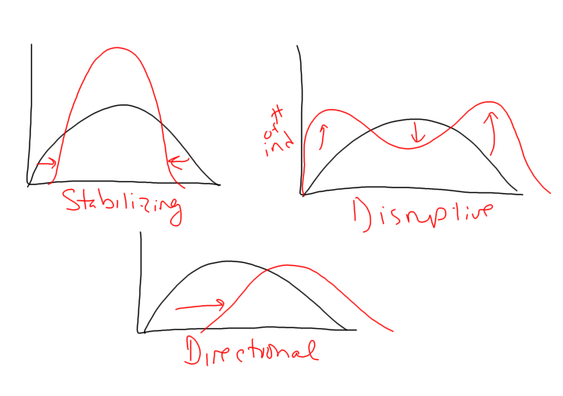
35.

